# **Activity - Optimize Utilization**

## **Activity overview**

In this activity, you will optimize the AWS resources that are used to run the Café web application. Specifically, you will:

1. Uninstall the decommissioned local database from the Café instance to decrease the instance’s storage requirements.
2. Change the instance type to T3 micro to reduce costs.  
   This diagram illustrates the topology of the Café web application runtime environment *before* and *after* the optimization.  
   **Before and after resource optimization topology diagrams:  
   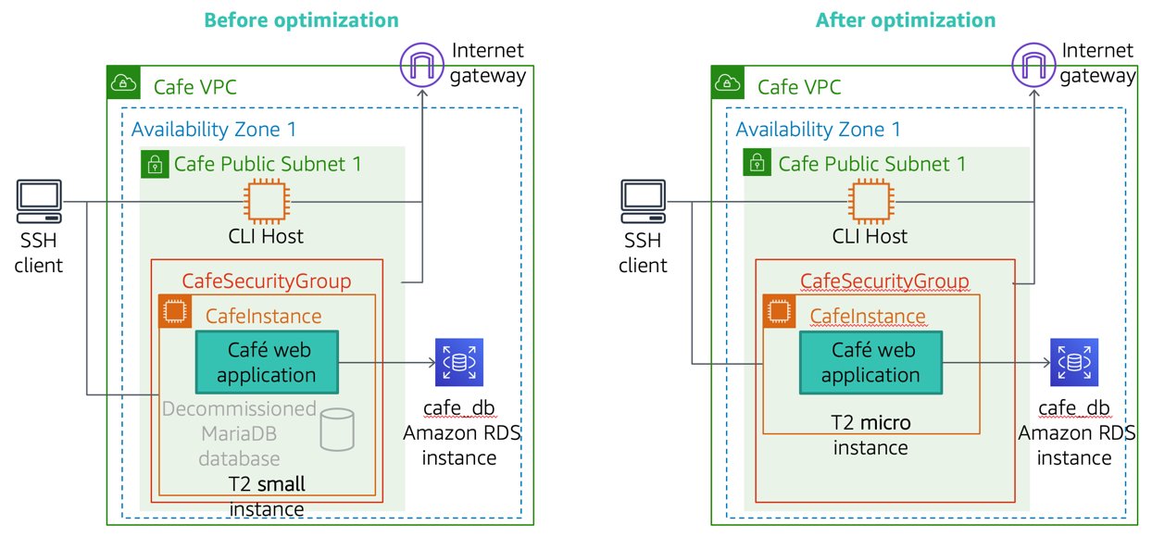**

## **Activity objectives**

After completing this activity, you will be able to:

* **Optimize** an Amazon Elastic Compute Cloud (Amazon EC2) instance to reduce costs.
* **Use** the AWS Pricing Calculator to estimate AWS service costs.

## **Business case relevance**

**A new business requirement for Café—Optimize resources to reduce AWS service costs**



After the migration to Amazon Relational Database Service (Amazon RDS) was completed (an action taken in a prior activity), Sofîa identified a number of optimization opportunities that she could implement to reduce AWS service costs. First, she realized that the decommissioned local database could be uninstalled to reduce the storage requirements of the Café instance. She also realized that the Café instance could be downsized to a smaller instance type because the database process was no longer running on it.

In this activity, you will take on the role of Sofîa, and work on optimizing the Café instance to save costs.

## **Activity steps**

**Duration:** This activity requires approximately **50 minutes** to complete.

## **Accessing the AWS Management Console**

1. At the top of these instructions, click Start Lab to launch your lab.  
   A Start Lab panel opens displaying the lab status.
2. Wait until you see the message "**Lab status: ready**", then click the **X** to close the Start Lab panel.
3. At the top of these instructions, click AWS  
   This will open the AWS Management Console in a new browser tab. The system will automatically log you in.  
   **Tip**: If a new browser tab does not open, there will typically be a banner or icon at the top of your browser indicating that your browser is preventing the site from opening pop-up windows. Click on the banner or icon and choose "Allow pop ups."
4. Arrange the AWS Management Console tab so that it displays along side these instructions. Ideally, you will be able to see both browser tabs at the same time, to make it easier to follow the lab steps.

## **Task 1: Optimize the website to reduce costs**

Because the local database was migrated to Amazon RDS, you can reduce AWS service costs by performing the following actions on the Café EC2 instance:

* Remove the local database from the instance. This action will reduce costs in both CPU and storage utilization.
* Change the instance type from t3.small to *t3.micro*. Because the database process no longer runs on the instance, the smaller instance type will be both effective and also cheaper to run.

In this task, you use the AWS Command Line Interface (AWS CLI) to perform these actions. You begin by opening a Secure Shell (SSH) session to the *Café instance* and the *CLI Host*.

### **Task 1.1: Connect to the Café instance by using SSH**

If you are a Windows user, follow the steps described in Task 1.1.1. Otherwise, if you are a macOS or Linux user, follow the steps in Task 1.1.2.

[macOS/Linux users—Click here for login instructions](https://labs.vocareum.com/web/1469070/423619.0/ASNLIB/public/docs/lang/en/README.html#ssh-macLinux)

#### **Task 1.1.1: Windows SSH**

These instructions are for Windows users only.

If you are using macOS or Linux, [skip to the next section](https://labs.vocareum.com/web/1469070/423619.0/ASNLIB/public/docs/lang/en/README.html#ssh-macLinux).

1. Read through the three bullet points in this step before you start to complete the actions, because you will not be able see these instructions when the Details panel is open.
   * Click on the Details drop down menu above these instructions you are currently reading, and then click Show. A Credentials window will open.
   * Click on the **Download PPK** button and save the **labsuser.ppk** file. Typically your browser will save it to the Downloads directory.
   * Then exit the Details panel by clicking on the **X**.
2. Download needed software.
   * You will use **PuTTY** to SSH to Amazon EC2 instances. If you do not have PuTTY installed on your computer, [download it here](https://the.earth.li/~sgtatham/putty/latest/w64/putty.exe).
3. Open **putty.exe**
4. Configure PuTTY to not timeout:
   * Click **Connection**
   * Set **Seconds between keepalives** to 30
5. This allows you to keep the PuTTY session open for a longer period of time.
6. Configure your PuTTY session:
   * Click **Session**
   * **Host Name (or IP address):** Copy and paste the public IP address for the **Instance** instance. To find it, return to the AWS Management Console, go to the EC2 service page and click on **Instances**. Check the box next to the CafeInstance and in the *Details* tab copy the **IPv4 Public IP** value.
     + **NOTE**: The setup for this lab takes a few minutes, because an RDS database instance must first be created before the CafeInstance EC2 instance is created, and RDS instances take a few minutes to create. If you do not yet set the CafeInstance EC2 instance, you will need to wait until the lab setup completes before you can complete this step.
   * Back in PuTTy, in the **Connection** list, expand **SSH**
   * Click **Auth** (don't expand it)
   * Click **Browse**
   * Browse to and select the lab#.ppk file that you downloaded
   * Click **Open** to select it
   * Click **Open**
7. Click **Yes**, to trust the host and connect to it.
8. When prompted **login as**, enter: ec2-user  
   This will connect you to the EC2 instance.
9. [Windows Users: Click here to skip ahead to the next task.](https://labs.vocareum.com/web/1469070/423619.0/ASNLIB/public/docs/lang/en/README.html#ssh-after)

#### **Task 1.1.2: macOS/Linux SSH**

These instructions are for Mac/Linux users only. If you are a Windows user, [skip ahead to the next task.](https://labs.vocareum.com/web/1469070/423619.0/ASNLIB/public/docs/lang/en/README.html#ssh-after)

1. Read through the three bullet points in this step before you start to complete the actions, because you will not be able see these instructions when the Details panel is open.
   * Click on the Details drop down menu above these instructions you are currently reading, and then click Show. A Credentials window will open.
   * Click on the **Download PEM** button and save the **labsuser.pem** file.
   * Then exit the Details panel by clicking on the **X**.
2. Open a terminal window, and change directory cd to the directory where the labsuser.pem file was downloaded.  
   For example, run this command, if it was saved to your Downloads directory:

cd ~/Downloads

1. Change the permissions on the key to be read only, by running this command:

chmod 400 labsuser.pem

1. Return to the AWS Management Console, and in the EC2 service, click on **Instances**. Check the box next to the **CafeInstance** and click on the *Details* tab.
   * **NOTE**: The setup for this lab takes a few minutes, because an RDS database instance must first be created before the CafeInstance EC2 instance is created, and RDS instances take a few minutes to create. If you do not yet set the CafeInstance EC2 instance, you will need to wait until the lab setup completes before you can complete this step.
2. Copy the **IPv4 Public IP** value.
3. Return to the terminal window and run this command (replace **<public-ip>** with the actual public IP address you copied):

ssh -i labsuser.pem ec2-user@<public-ip>

1. Type yes when prompted to allow a first connection to this remote SSH server.  
   Because you are using a key pair for authentication, you will not be prompted for a password.

#### **Task 1.1.3: Configure the AWS CLI**

Before you can run AWS CLI commands on the instance, you must first configure the AWS CLI environment to define the AWS account credentials, Region name, and output format to use.

Discover the region in which the CLI Host instance is running:

curl http://169.254.169.254/latest/dynamic/instance-identity/document | grep region

You will use this region information in a moment.

Update the AWS CLI software with the credentials.

aws configure

At the prompts, enter the following information:

* + **AWS Access Key ID**: Click on the Details drop down menu above these instructions, and then click Show. Copy the **AccessKey** value and paste it into the terminal window.

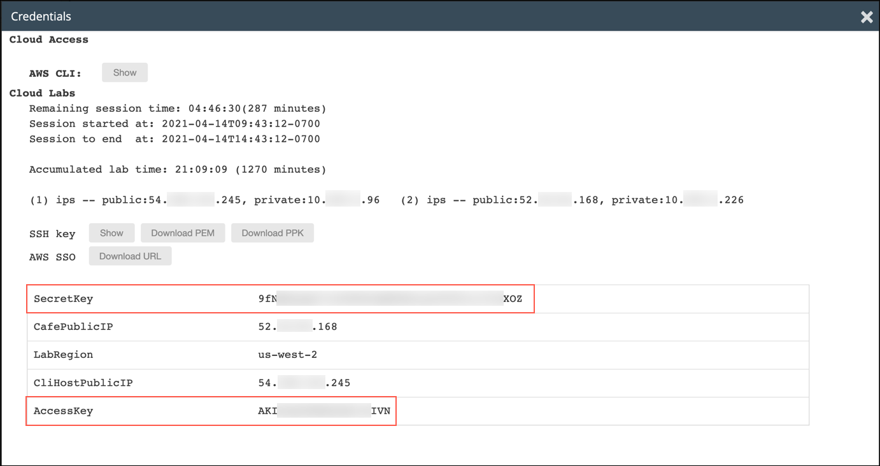

* + **AWS Secret Access Key**: Copy and paste the **SecretKey** value from the same Credentials screen.
  + **Default region name**: Type in the name of the region where your EC2 instances are running, which you just discovered a moment ago. For example, us-east-1 or eu-west-2.
  + **Default output format**: json

Leave this terminal window SSH session open. You will return to use it later in the activity.

### **Task 1.2: Connect to the CLI Host instance by using SSH**

Follow the same instructions that you used in Task 1.1 to open an SSH session to a different EC2 instance—the **CLI Host** instance.

Do not close the connection to the CafeInstance, instead, create a connection to the CLI Host in a new window (using putty on Windows or using an additional terminal window on macOS/Linux).

You can find the CLI Host public IP address in the EC2 console, or by clicking on the Details drop down menu above these instructions, and then click Show.

After connecting, be sure to also configure the AWS CLI client software on the CLI Host EC2 instance, by running the aws configure command.

### **Task 1.3: Uninstall MariaDB and resize the instance**

Stop the local database and uninstall it from the Café instance. In the **SSH window for the CafeInstance**, enter:

sudo systemctl stop mariadb

sudo yum -y remove mariadb-server

If the last command runs successfully, you will see a *Complete!* message in the output.

Close the **SSH window for the CafeInstance** because you no longer need it.

Determine the **Instance ID** of the CafeInstance. Switch to the **SSH window for the CLI Host instance** and enter:

aws ec2 describe-instances \  
--filters "Name=tag:Name,Values= CafeInstance" \  
--query "Reservations[*].Instances[*].InstanceId"

Record the value returned as:

CafeInstance Instance ID: i-nnnnnnnnnn

Stop the Café instance and change its instance type to **t3.micro**. In the **SSH window for the CLI Host instance**, enter:

aws ec2 stop-instances --instance-ids <CafeInstance Instance ID>

In the command, substitute *<CafeInstance Instance ID>* with the value that you recorder earlier.

Change the instance type to **t3.micro**. In the **SSH window for the CLI Host instance**, enter:

aws ec2 modify-instance-attribute \  
--instance-id <CafeInstance Instance ID> \  
--instance-type "{\"Value\": \"t3.micro\"}"

In the command, substitute *<CafeInstance Instance ID>* with the value that you recorder earlier.  
If the command completes successfully, no output is returned.

Start the Café instance. In the **SSH window for the CLI Host instance**, enter:

aws ec2 start-instances --instance-ids <CafeInstance Instance ID>

In the command, substitute *<CafeInstance Instance ID>* with the value that you recorder earlier.

Check the current state of the instance, and wait until the status shows *running*. In the **SSH window for the CLI Host instance**, enter:

aws ec2 describe-instances \  
--instance-ids <CafeInstance Instance ID> \  
--query "Reservations[*].Instances[*].[InstanceType,PublicDnsName,PublicIpAddress,State.Name]"

In the command, substitute *<CafeInstance Instance ID>* with the value that you recorder earlier.

The instance might take a few moments to reach the *running* state. Periodically repeat the command until you can confirm that it is running. Also, record the **PublicDnsName** and **PublicIPAddress** values that are returned by the command by using the following format:

Downsized CafeInstance Public DNS Name: ec2-zzz-zzz-zzz-zzz.eu-west-2.compute.amazonaws.com  
Downsized CafeInstance Public IP Address: nnn.nnn.nnn.nnn

**Information**: Because you restarted the instance, Amazon EC2 will assign a different *Public DNS name* and *Public IP address* to the instance than what it had before.

Test the Café website to make sure that it is functional. In a browser window, enter the following URL:

http://<Downsized CafeInstance Public DNS Name>/cafe

Substitute *<Downsized CafeInstance Public DNS Name>* with the value that you recorded.

Exercise the website's functions to verify that it works properly.  
Great job! You have successfully uninstalled the decommissioned local database and downsized the Café instance.

## **Task 2: Use the AWS Pricing Calculator to estimate AWS service costs**

AWS provides a tool that allows you to estimate the monthly costs of the AWS services that you use or are planning to use. In this task, you will use the AWS Pricing Calculator to estimate the cost of running the Café website on AWS before and after EC2 instance optimization. You will then calculate the projected cost savings.

**NOTE:** The values that you will enter into the AWS Pricing Calculator have been simplified to serve the purposes of this exercise. The intent is to show you the basic use of the calculator and highlight the functions that it provides.

The pricing examples shown in this activity were current as of time of publishing, April 2020, and is for informational purposes. Refer to the AWS website for current pricing by service.

### **Task 2.1: Calculate the costs before optimization**

First, calculate the costs of running the website in its *before optimization* topology, that is, on a *T3 small* instance with *a decommissioned local database still occupying storage space*.

Specifically, you will use the following service list and configuration to describe the topology components:

* Region: (the region where the CafeInstance EC2 instance is running)
* Amazon EC2 instance:
  + Instance type: **t3.small**
  + Instance class: **On-Demand**
  + Utilization: **100% per month**
  + Operating system: **Linux**
  + Amazon EBS volume: **General Purpose SSD (gp2), 40 GB** (including 20 GB occupied by the local database)
* Amazon RDS instance:
  + Instance class: **db.t3.micro**
  + Engine: **MariaDB**
  + Allocated storage: **20 GB**

1. Open the AWS Pricing Calculator. In a web browser, go to:

https://calculator.aws

Click on **Create estimate**.

1. Browse down and choose **Configure** in the **Amazon EC2** service box.
2. In the **Region** menu at the top of the page, select the region where the CafeInstance EC2 instance is running.  
   For example, choose US East (N. Virginia) if your instances is running in us-east-1.  
   If you are prompted to confirm the region change, choose **Change Region**.
3. Choose the **Advanced estimate** option.
4. In the *EC2 instance specifications* area, for the Operating system, choose **Linux**
5. In the **Workload** area:
   * Choose **Constant usage**.
   * For **Number of instances** choose 1.
6. In the *EC2 instances* area, in the search box, search for and then select the **t3.small** instance type.
7. In the *Pricing strategy* area, set the pricing model to **On-Demand**
8. In the *Amazon Elastic Block Storage (EBS)* area:
   * Storage for each EC2 instance: **General Purpose SSD (gp2)**
   * Storage amount: **40 GB**
   * Snapshot Frequency: **No snapshot storage**
9. Scroll to the bottom and select **Add to my estimate**.  
   Congratulations, you have now estimated the cost of the EC2 instance.  
   Next, you will add the RDS instance to your price estimate.
10. In the *My Estimate* page, click **Add service**.
11. In the *Select service* page, locate and click **Configure** in the **Amazon RDS for MariaDB** service panel.
12. Configure as follows:
    * Region: (choose the same Region you chose for the EC2 instance)
    * MariaDB instance specifications: **Standard (single-AZ)**
    * Instance type: search for and select **db.t3.micro**
    * Quantity: **1**
    * Pricing model: **On-Demand Instances**
    * Storage volume: **General Purpose SSD (gp2)**
    * Storage amount: **20 GB per month**
13. Choose **Add to my estimate**.  
    The My Estimate page shows a breakdown of the estimated monthly cost of the AWS services that you configured, and it provides a monthly total.
14. Choose **Save and share**.  
    If prompted, choose **Agree and continue**.  
    Choose **Copy the public link** and paste the link into another browser tab.  
    This is the estimated cost of your *before optimization* topology.  
    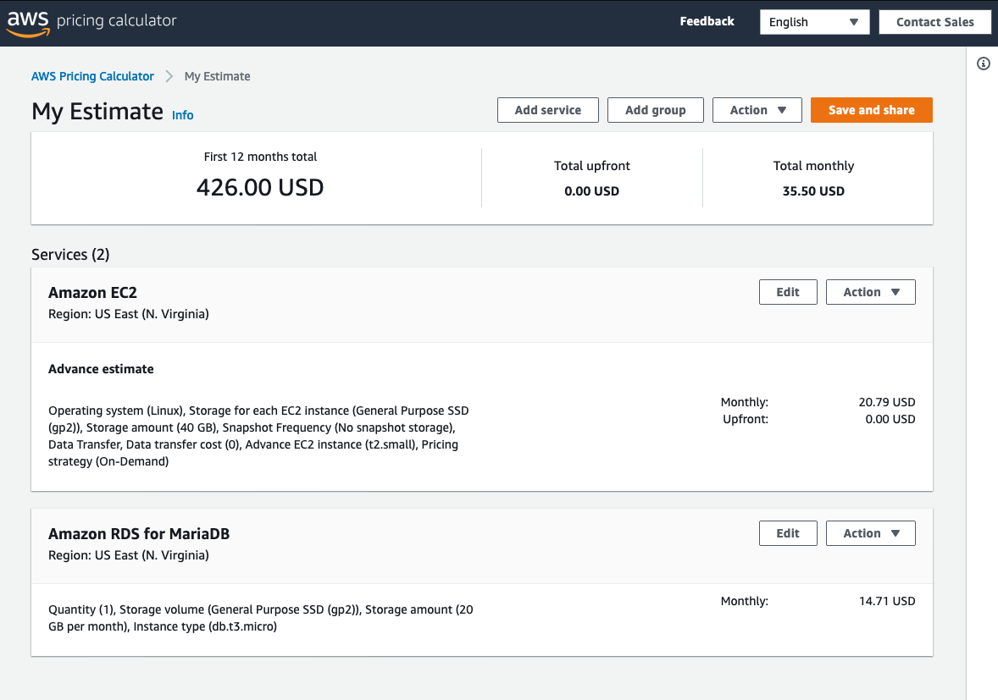
15. Export the estimate to a comma-separated values (CSV) file by choosing **Action > Export estimate**.
16. In the export dialog window, click **OK** and save the file to your local computer. You can optionally open it to see its contents.
17. Record the total estimated monthly cost (for example, *$35.50*) as:

AWS Services Before Optimization Estimated Monthly Cost: $35.50

### **Task 2.2: Calculate the costs after optimization**

Next, you will calculate the costs of running the website *after the Café instance was optimized*. Specifically, you will modify the following entries in the calculator to reflect the effects of the optimization:

Amazon EC2 instance:

* Instance type: **t3.micro** (Reduced size)
* Amazon Elastic Block Store (Amazon EBS) General Purpose SSD (gp2), **20 GB** (Reduced from 40 GB because the local database was removed)

1. In the<https://calculator.aws/#/estimate> browser tab, click **Edit** next to the **Amazon EC2** entry.
2. In the *EC2 Instances* area, search for and select **t3.micro** as the instance type.
3. In the *Amazon Elastic Block Storage (EBS)* area, change the **Storage amount** to 20 GB.

Scroll down and click **Save** to see the monthly cost estimate.  
The *My Estimate* page should show the estimate of

1. your monthly costs for the *after optimization* topology.  
   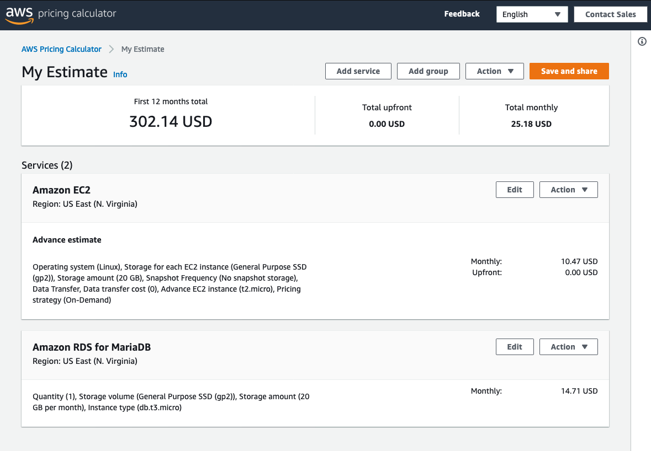
2. Export the estimate to a comma-separated values (CSV) file by choosing **Action > Export estimate**.
3. In the export dialog window, click **OK** and save the file to your local computer. You can optionally open it to see its contents.
4. Record the total estimated monthly cost (for example, *$25.18*) as:

AWS Services After Optimization Estimated Monthly Cost: $25.18

### **Task 2.3: Estimate the projected cost savings for Café**

Because you calculated the costs of the AWS services that are needed to run the Café website both before and after you optimize the instance, you can estimate the overall projected cost savings as follows:

Before optimization monthly costs:

- Amazon RDS service $14.71

- Amazon EC2 service $20.89

--------

Total $35.60

​

After optimization monthly costs:

- Amazon EC2 service $10.47

- Amazon RDS service $14.71

--------

Total $25.18

​

​

Overall monthly cost savings $10.42

* Pricing is current as of time of publishing, April, 2020, and is for demonstration purposes only. Refer to the AWS website for current pricing by service.

Congratulations! By removing the decommissioned local database and downsizing the Café instance type, you will save more than *$10 per month* in AWS service costs.

**Update from Café**



Martha and Frank are very happy that Sofîa's initiative resulted in cost savings for the business. The amount of savings might be small, but it still helps the business!

## **Activity Complete**

Congratulations! You have completed the activity.

1. Click End Lab at the top of this page and then click **Yes** to confirm that you want to end the lab.   
    A panel will appear, indicating that "DELETE has been initiated... You may close this message box now."
2. Click the **X** in the top right corner to close the panel.